

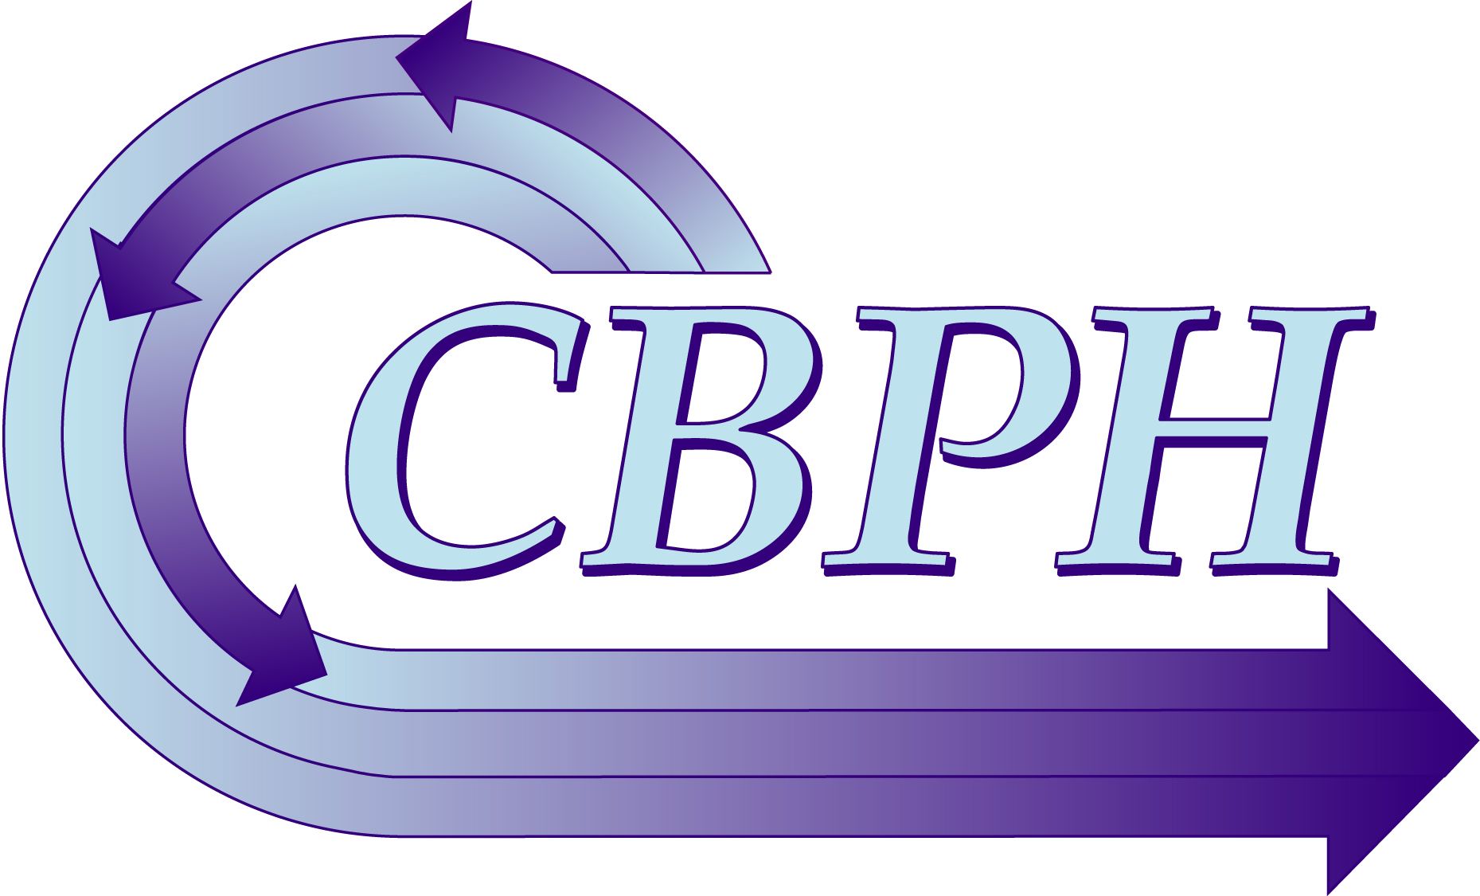

2014

Community-Based Public Health
Caucus Abstract Guide
Community Based Public Health Caucus
How to Write an Abstract Guide

The Community-Based Public Health Caucus invites abstracts related to the science and practice of community-based public health for the 142nd American Public Health Association Meeting and Exposition to be held from November 15-19 in New Orleans, LA. The theme of the 2014 meeting is Healthography: How Where You Live Affects Your Health and Well-Being, and we have particular interest in abstracts and proposals that reflect this theme.

CALL for ABSTRACTS for the 2014 ANNUAL MEETING: We invite abstracts that advance our knowledge of community-academic partnering in multi-disciplinary collaboration and a diversity of community-based public health activities, including basic and applied research projects, interventions, teaching and service learning projects. Of particular interest are presentations of initiatives that put community- based organizations in the lead position. Presentations that provide participants with enhanced knowledge and skills to conduct community-based public health activities as well as those that explicitly describe the application of community-based participatory research (CBPR) to promoting healthy communities especially through policy change and decision-making at the local, state and federal level, are also of great interest. We are particularly interested in abstracts that address:

- Academic-community partnerships: the good, the bad, and the ugly
- Benefits & power of partnerships
- Community Voices: community member perspectives on community-academic partnerships and CBPR (presenting author must be a community member)
- Community-led ethics review of CBPR: Community IRBs, tribal IRBs and community research review committees
- Global community-based public health
- Healthography and CBPR
- Patient-centered outcomes research and CBPR: What can we learn from each other?
- Research to Action: Translation of CBPR into practice and/or policy
- Lessons learned from community based participatory research projects
- Measures, methods, and evaluation in CBPR
- Youth Roundtable: Youth leading the way to healthier communities (presenting author must be a student/youth)
- The role of community partners in community based public health

We are also looking for abstracts on efforts to use community-university partnerships or other types of collaborations, the development of partnerships, capacity-building, dissemination approaches for CBPR findings, and innovative strategies, programs, models, and best practices to address community based public
health issues. Each contributed abstract must be categorized under one of the topics or areas of interest described in the call for abstract. The deadline for submitting abstracts to the CBPH caucus is February 12, 2014.

Authors are encouraged to submit abstracts on current and emerging public health issues. Per American Public Health Association (APHA) guidelines there can only be one presenting author. To submit an abstract for consideration and presentation during the APHA Annual Meeting, you do not need to be an APHA member. However, if your abstract is accepted for presentation, the presenter MUST become an APHA individual member in good standing at the time of the meeting. In addition, the presenter MUST register for the Annual Meeting.

I. What is an abstract?

An abstract is a brief summary of your work, intervention and/or research. It is designed to inform the reader about your project/research in a concise manner. Abstracts must be 250 words or less and provide a brief description of what to expect in your presentation. It should include the following components 1) Introduction - Statement of the research problem, purpose and/or hypothesis 2) Methods, 3) Results and 4) Discussion. In addition, because it is a conference abstract, the author should indicate how it relates to the theme of conference and the mission of the community based public health caucus.

Questions to consider when addressing each component (University of
California, Berkeley, 2000):

1) Motivation/problem statement: Why do we care about the problem? What practical, scientific/theoretical gap is your research or community based intervention filling?

2) Methods/procedure/approach: What did you actually do to get your results? (e.g., analyzed 3 novels, completed a series of 5 oil paintings, interviewed 17 students)

3) Results/findings/product: As a result of completing the above procedure, what did you learn, invent, create, observe? Was there enhanced knowledge, increased participation, self efficacy, etc.?

4) Conclusion/implications: What are the larger implications of your findings, especially for the problem/gap identified in step 1?

II. What is the format of the abstract and learning objectives?

Abstracts should be written in 12 pt font; single spaced. Abstracts must be limited to 250 words or less. Please develop your abstract off-line before accessing the online submission form. Use the spell checking and word count features of your word processor to check the text of the abstract before submitting it.

Many APHA attendees use the annual meeting for continuing education therefore presenters must demonstrate how attending their presentation would be a learning experience for attendees. Learning objectives must be included with your submission (Learning Objectives WILL NOT be included in the abstract text word count). Learning objectives must be measurable. Presenters should check with their planners prior to the session to see if CEU’s will be offered for their session.

Guidelines for Writing Learning Objectives

The following guidelines are provided to assist in the development of appropriate learning objectives for a proposed educational experience. In order to develop appropriate Learning Objectives you MUST follow the format shown in the Example of Learning Objectives below. NO COMPOUND OBJECTIVES.

Step 1. Describe the information, skills, behaviors, or perspectives participants in the session will acquire through attendance and participation.
Step 2. Clearly identify the outcomes or actions participants can expect to demonstrate as a result of the educational experiences. See the action words below. Step 3. Write the learning objectives that relate to these outcomes and that reflect the content of the session. Objectives describe the behavior of the learner, and:
▪ are stated clearly
▪ define or describe an action
▪ are measurable, in terms of time, space, amount, and/or frequency

Measurable Action Words (examples)

Explain | Demonstrate | Analyze | Formulate | Discuss
Compare | Differentiate | Describe | Name | Assess
Evaluate | Identify | Design | Define | List

Examples of Learning Objective
1. List five factors that contribute to hypertension
2. Describe the procedure for assessing the health status of a patient with cancer
3. Design a community based breast screening model

III. Example of abstracts

Community based public health abstract
OBJECTIVES: Colorectal cancer is the third leading cause of death that disproportionately affects the poor and underserved. A community-based participatory approach (CBPR) is a promising approach to prevent colorectal cancer in this population. The collaborative development of a theory-grounded, randomized-controlled trial designed to test two colorectal cancer screening interventions through fecal-occult blood testing (total participant n=1050) is described, with an emphasis on how community and academic partners worked together to design intervention and research components.
METHODS: Empowering Communities for Life (EC4L) takes place in two underserved counties in the Arkansas Lower Mississippi Delta with marked health disparities. The program arose from a 9-year partnership between academics and nine Cancer Councils across Arkansas. Community and academic partners collaborated over 25 months to develop research infrastructure, intervention materials and methods, and the assessment instrument.
RESULTS: Strengthened community-academic partnerships, certification in Human Subjects and HIPPA, development of a randomized controlled design to test the intervention's efficacy, an interactive PowerPoint presentation, an informational pamphlet, the certification of 6 lay health advisors and 22 role models, and an assessment tool are project development outcomes. Additionally, several lessons were learned about working collaboratively with diverse groups.
CONCLUSIONS: Few studies have developed a community-based colorectal cancer prevention intervention for an at-risk population using a participatory approach. EC4L is a useful model for community-based interventions seeking to incorporate sound research methodology and health behavior theory to increase colorectal cancer screening among rural, underserved African Americans and Caucasians in the context of eliminating social disparities in health.
Learning Objectives:
1. Describe how community and academic partners worked together to develop intervention materials and methods. 2. Describe how community and academic partners worked together to develop an assessment instrument. 3. Name at least 3 strategies when working collaboratively with diverse groups. 4. Discuss the importance of community involvement in research.
IV. How do I submit my abstract on line?

To submit an abstract, visit http://apha.confex.com/apha/142am/cbph.htm and click on the start abstract submission tab. Upon clicking on this tab you will be given an abstract ID and password and asked to follow step by step instructions. There are 6 steps to submitting an on-line abstract.

- Select a topic
- Enter the title of your abstract
- Select preferred presentation format
- Enter the learning objectives
- Submit the names of the authors and their affiliations
- Sign the disclosure form (Conflict of Interest)- presenting authors
- Submit the text of the abstract

Once you have submitted your abstract you will receive an email confirmation that will also provide you with your abstract ID and password, it is advised that you keep it in a safe location because you have the option to edit, modify and delete you’re abstract until the deadline of February 12, 2014. On the abstract control pane located on the left side of the page, there are helpful instructions and troubleshooting tips to help should you need further assistance.

V. How is the abstract reviewed?

Abstracts are peer-reviewed by community and academic members of the Caucus. They will be considered for oral, poster or roundtable presentation, unless authors indicate a preference. Abstracts are evaluated for their quality and the degree to which their content is consistent with the vision of the Community-Based Public Health Caucus and the 2014 APHA Meeting theme, Healthography: How Where You Live Affects Your Health and Well-Being. If your abstract is accepted for presentation, you are REQUIRED to present material as stated in the peer-reviewed abstract.

Specifically, abstracts are reviewed using the following criteria:
- Consistent with the vision of the CBPHC (see http://www.sph.umich.edu/cbphcaucus/about/vision.html for information about the Caucus
- Evidence of community-engaged research/practice and the role played by the community
- Scientific strength
- Addresses social determinants of health
- Relevance of research/practice (e.g., significance, importance explained)
- Discusses at least one of the following issues: Lessons learned, barriers to trust, social change, social justice, social action, health equity, community engagement, community participation, community empowerment, community led, capacity building, and sustainability.

VI. What is the timeline for abstract submission, notification and other related APHA events?
February 12, 2014 | Deadline for Abstract submission. No exceptions!
June 2, 2014 | Email Notification of status sent to Abstract submitters
July 31, 2014 | Official APHA presenter letter available online to all pre- registered presenters. Letter will include day, date, and time and room location.
August 15, 2014 | Deadline to withdraw an abstract without penalty
September 26, 2014 | Final Advance Registration Deadline  Presenters must be registered by this date
October 19, 2014 | APHA Housing Services Reservation Deadline
November 14, 2014 | Deadline for Oral Session Presenters to upload their presentations. Deadline for oral and roundtable session presenters to upload a short bio for session
November 15-19, 2014 | APHA Annual Meeting in New Orleans, LA

VII. Who should I contact if I need additional information?

For more information regarding this submission please feel free to contact:

Larkin Strong, CBPH Caucus Academic Program Planner at LLstrong@mdanderson.org or

Olufunke Akiyode, CBPH Caucus Community Program Planner at adesuwaak@yahoo.com

For more information about the CBPH Caucus, see www.cbphcaucus.org

References:

University of California, Berkeley Office of Sponsored Research (2003). How to write an abstract: Links and Tips. Retrieved on November 3, 2010 from http://research.berkeley.edu/ucday/abstract.html

Useful links with helpful tips are below:

www.unc.edu/depts/wcweb/handouts/abstracts.html www.linguistics.ucsb.edu/faculty/bucholtz/sociocultural/abstracttips.html www.academic-conferences.org/abstract-guidelines.htm http://ling.wisc.edu/~macaulay/800.abstracts.html http://writingcenter.unlv.edu/writing/abstract.html http://www.lightbluetouchpaper.org/2007/03/14/how-not-to-write-an-abstract/ http://webapp.comcol.umass.edu/msc/absGuidelines.aspx http://www.oberlin.edu/history/Honors/prospectus.html http://www.english.eku.edu/ma/scholarlythesis.php

